**identity a secret.**

He produces pieces of work which pop up in public places, such as on the walls of buildings. **Banksy is a famous - but anonymous - British graffiti artist. He keeps his**

A lot of his art is done in a particular style which people can easily

Banksy was heavily influenced in his early days by a French graffiti artist called Blek le Rat. Not only did this artist inspire Banksy politically, but Banksy was also inspired by his use of stencils.

Banksy took on this visual style for himself and, to this day, uses stencils to do a lot of his work. 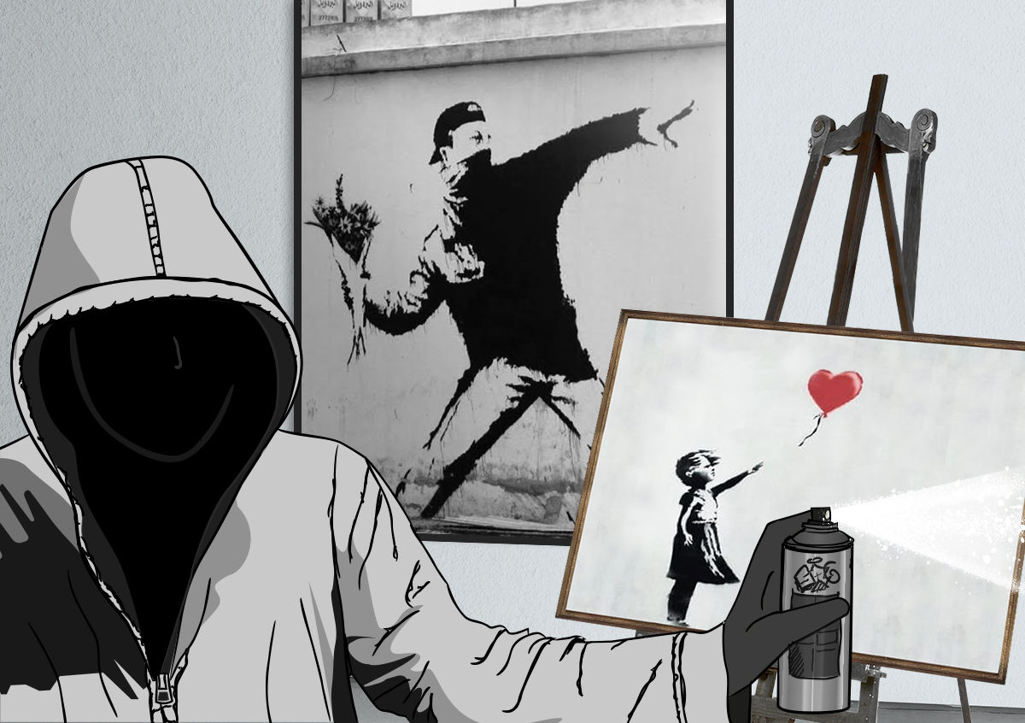

Това е за потртера/снимката на художника

